Method Overloading
Method overloading is a feature in Java where multiple methods in the same class have the same name but different parameter lists.

Method signature consist of the name of the method, and the uniqueness of the declaration of its parameters. In other words a signature is unique not just by the method name, but in combination with number of parameters, their types and the order in which they are declared.
return type is not a part of signature.
The difference can be in the number, type, or order of parameters, but not in the return type alone.
It is a form of compile-time polymorphism, because the method to be executed is determined by the compiler at compile time based on the arguments passed.

Method overloading allows the same method name to perform different tasks based on input parameters, enabling compile-time polymorphism in Java.

While resolving overloaded methods, Java prefers widening over autoboxing, and autoboxing over varargs.

Widening
If exact match not found Java prefers converting small primitives to large primitives
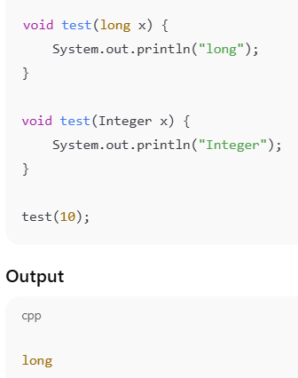
AutoBoxing
If exact match is not found then java prefers Autoboxing

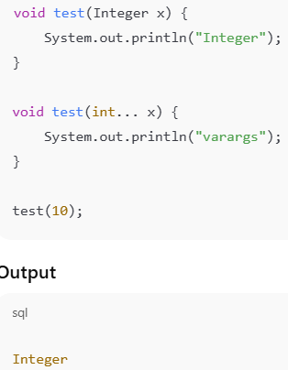
Varags
Varargs are used only if no better match exists.
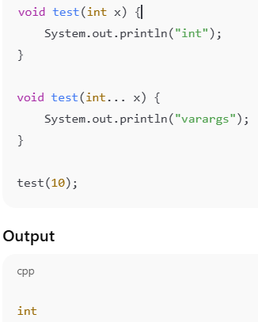

Advance Switch statement
The enhanced switch statement in Java is a modern switch expression that uses arrow syntax, eliminates fall-through, allows returning values, and improves code readability and safety
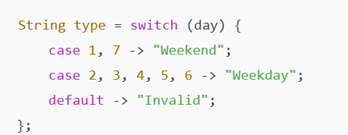
Switch was only usable with primitive types and Enum like (short, byte, int, char, string and enum also their object version).
Switch can’t use float, double, Boolean or their wrapper classes.

Enhanced switch return null values also.
If we return any value from switch , default statement is mandatory.
With enhanced switch we can use return keyword just before the switch.

With code block in switch statement if we want to return any value, we required “YIELD” keyword.
Switch statements require yield for block returns and can return values safely at compile time.
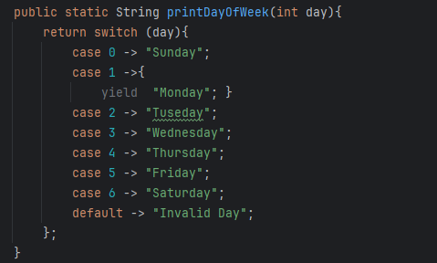

Default methods
It’s introduced in java 8 and it’s a method inside an interface with a concrete implementation.
To support backward compatibility it allows adding new methods to existing interfaces without breaking implementing classes.
If a class implements multiple interfaces with same default method, compiler error occurs to resolve this class must override the method using super.methodName().
Defualt method can’t be final but it can be private after java 19+.

Functional Interface
Introduced in java 8, functional interface have only one abstract method in it.
it came to support lambda expression.
This is annotated by @functionalInterface, it’s optional but recommended to avoid mistake.
Functional interface can have any number of default methoad and also any number of static method.
Functional interface don’t have instance variable but they do have constants (static final).
It can extends another interface only if both have at most 1 abstract method.
Some built in functional interfaces are:
Runnable -> void run() -> no input, no output
Supplier(T) -> T get() -> no input, returns output
Consumer (T) -> void accept(T) -> takes input, no output
Predicate (T) -> Boolean test(T) -> condition checking
Function < T,R > -> R apply(T) -> input – output

Streams
Stream in Java is a sequence of elements that supports functional-style operations for processing collections efficiently .
Iterators are used to traverse data, while Streams are used to process data declaratively and efficiently using functional programming. Iterator processes everything eagerly while stream processes only what is required.
Stream does not store the data it just process the data., not original collection is changed.
Stream can be created from collections, Arrays, I/O channels, Stream Generators.
Stream can be processed only once.
Lazy evaluation : Stream operation do not execute until a terminal operation is called. It improve performance by avoding unnecessary computations.
Stream pipeline: stram pipeline consists of 3 parts:
Source Intermediate Operation Terminal operations

Intermediate Operations: these can return a stream, execute lazily or can be chained, like filter(), map(), sortes(), distinct().

Terminal Operations: This produce a result. It trigger stream execution and end the stream. Like forEach(), collect(), toList(), count(), findFirst(), anyMatch()

